|  |  |  |
| --- | --- | --- |
| Use Case ID: | UC1 | |
| Use Case Name: | Booking parking | |
| Actors: | Customer | |
| Pre-conditions: | Customer sign into the system | |
| Post-conditions: | System get available slot for the customer vehicle | |
| Flow of events: | **User Action** | **System Action** |
| 1- User enter email and password. |  |
|  | 2- System authenticate user data.  3-System ask the user for vehicle data |
| 4-User insert vehicle data. |  |
|  | 5-System display a list of available slot that fits the vehicle's data. |
| 6-User reserve the suitable slot. |  |
| Exceptions: | **User Action** | **System Action** |
| 1- User enter email and password. |  |
|  | 2- User details is invalid and unreadable. |
|  | 3-User search for available slot. |  |
|  |  | 4-System cannot find available slot. |
| Includes: | None | |
| Notes and Issues: | If there's no slot ,the system returns an empty list. | |

|  |  |  |
| --- | --- | --- |
| Use Case ID: | UC2 | |
| Use Case Name: | Modify parking slot | |
| Actors: | Admin | |
| Pre-conditions: | Admin view accounts that sign in the application. | |
| Post-conditions: | Admin modify the slots list. | |
| Flow of events: | **User Action** | **System Action** |
| 1. Admin open the system to insert data. 2. Admin insert the number of slots and the dimensions | 3-System display empty list of slots to fill it with data. |
|  | 4-System display selection button to choose which configuration admin want. |
| 4-Admin select the configuration which customers will park their vehicle based on it. |  |
|  | 5-System save the data. |
| 6-Admin view accounts of customers who sign in and insert data of their vehicles.  7-Admin view list of slots that he filled and specify a slot for each customer. |  |
|  |  | 8-System save the data that the admin insert . |
| Exceptions: | **User Action** | **System Action** |
| 1- Admin want to select the configuration that he want. |  |
|  | 2- System display only one configuration |
|  | 3-Admin specify a slot depending on vehicle data. |  |
|  |  | 4-System cannot find available slot that fits vehicle data. |
| Includes: | None | |
| Notes and Issues: | None | |

SequenceID:1

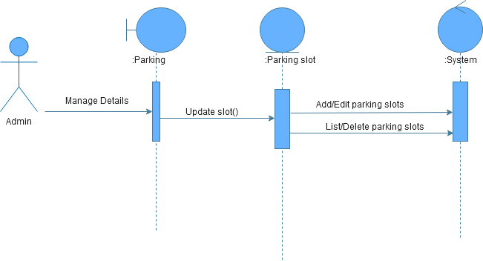

SequenceID:2

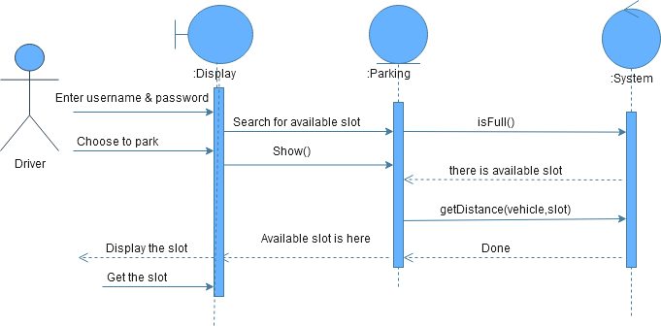

SequenceID:3

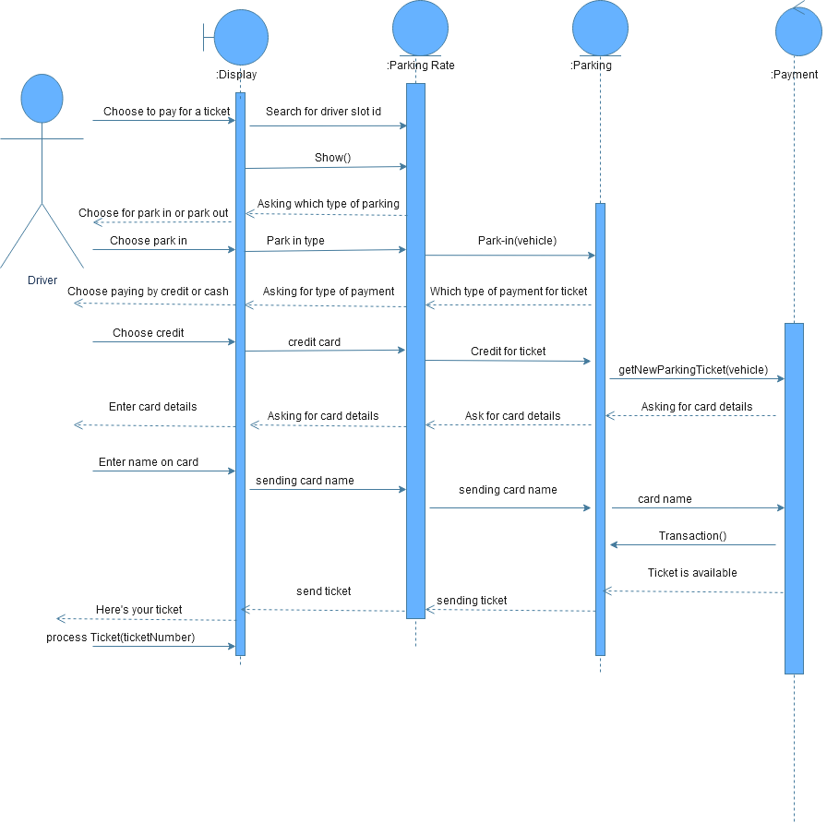

Class-Sequence Table

| **Class Name** | **Sequence Diagrams** | **Overall used methods** |
| --- | --- | --- |
| Parking | 1, 2 ,3 | isFull, getDistance,updateSlot,getNewParkingTicket |
| Parking slot | 1 | None |
| Display | 2,3 | Show |
| Parking Rate | 3 | Park-in |
| Payment | 3 | Transaction |